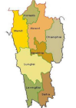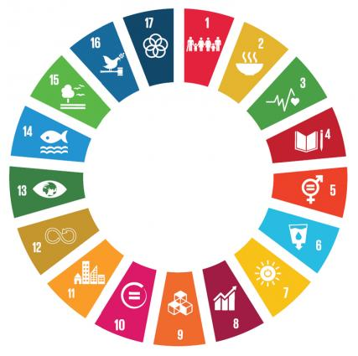

**REGIONAL WORKSHOP ON**

**SUSTAINABLE DEVELOPMENT GOALS**

*24TH AUGUST 2018 AT ATI AUDITORIUM,*

*NEW SECRETARIAT COMPLEX, AIZAWL, MIZORAM.*

**PROCEEDNGS**

***Sponsored by***

***NORTH EASTERN COUNCIL (NEC)***

**Ministry of Development of North East Region**

**Government of India, Shillong, Meghalaya**

***Organized by***

## **PLANNING & PROGRAMME IMPLEMENTATION DEPARTMENT**

***GOVERNMENT OF MIZORAM***

***FOREWORD***

The Sustainable Development Goals need concerted and coordinated efforts to move away from the internationally driven goals and targets to locally and regionally driven operations. To localize the effort entails focus attention on local capacity development, building ownership and responsibility. Localization becomes an important element for implementing the SDGs. It will improve monitoring of progress within and between the sub groups – gender and marginalized people in different areas.

Recognizing the importance of Localization of SDGs, the ‘Regional Workshop on Sustainable Development Goals’ was organized by Planning & Programme Implementation Department, Government of Mizoram on 24th August 2018 (Friday) at the ATI Auditorium, Aizawl, and Mizoram. The North Eastern Council, Ministry of Development of North Eastern Region, Government of India sponsored the Workshop.

The Workshop had many objectives which inter alia include the SDGs localization process, regional cooperation among the North Eastern States and sharing good practices and examples. Key issues and deliberations of the Workshop are incorporated in this report.

(Dr. C.VANLALRAMSANGA)

Secretary to the Government of Mizoram

Planning & Programme Implementation Department

|  |  |  |
| --- | --- | --- |
|  | CONTENTS |  |

|  |  |  |
| --- | --- | --- |
| Sl. No | Technical Paper | Page Number |
| 1 | Report |  |
| 2 | Localizing SDG at the Sub-State Level in the North East India  *Mr. Sundar Narayan Mishra* |  |
| 3 | SDG National Indicator framework  *Mr. Akhilesh Kumar* |  |
| 4 | Overview of SDGs  *Supriya Khound* |  |
| 5 | Sensitizing and Engaging Local Stakeholders – District and Local Communities on SDGs  *Mr. J.C. Phukan* |  |
| 6 | Deliberations |  |
| 7 | Photo Vision of the Regional Workshop |  |

**REPORT ON REGIONAL WORKSHOP ON SUSTAINABLE DEVELOPMENT GOALS PROGRAMME HELD ON 24th AUGUST 2018 AT ATI AUDITORIUM, NEW SECRETARIAT COMPLEX, AIZAWL, MIZORAM.**

A one day Regional Workshop on Sustainable Development Goals (SDG) Programme for North East States was held on 24th August 2018 at ATI Auditorium in Aizawl, Mizoram. The event brought together key officials from Niti Aayog, MosPI, UNDP and officers in charge of SDGs from North East States of Arunachal Pradesh, Assam, Manipur, Meghalaya and Mizoram, officials from Government of Mizoram, lecturers and students from selected colleges within Aizawl to discuss the concept of the United Nation’s Sustainable Development Goals, its implementation strategy, sensitizing and localizing the SDGs at sub-state level. The workshop was divided into three sessions- inaugural session followed by two technical sessions. Workshop Program can be seen at Annexure.

**Inaugural Session**

The workshop started with opening remarks from Dr C. Vanlalramsanga, Secretary Planning & Programme implementation Department. He welcomed and thanked all the dignitaries, speakers, all participants and representatives from the North East States and thanked the North East Council for their Financial Assistance without which the workshop would not materialize. He highlighted what Mizoram has achieved so far in implementation of the UN’s Sustainable Development Goals.

Prof. K.R.S. Sambavisa Rao, Vice Chancellor, Mizoram University noted that the North Eastern States have huge advantages in certain sectors such as tourism, human resources, horticulture etc. However, basic things of primary fundamental requirements needs such as road connectivity, solid waste management, rain water harvesting; agriculture price policy etc. needs to be improved.

Lt. Gen (Dr) Anil Kumar, (Retd) Vice chancellor, ICFAI University, Mizoram addressing the workshop stated that as far as Mizo people are concern, Sustainable Development Goals is already being followed to some extent.

The Hon’ble Chief Guest, Pu Lalsawta, Minister Planning, Finance, Taxation and Law & Judicial stated that though the framework of United Nation’s Sustainable Development Goals is a fairly new concept for the State, we have been unconsciously working towards achieving these goals from the past decades through various development schemes of the Government. He also mentioned that Mizoram is a young State which attain Statehood only in 1987 and we are on the path of economic development only since the last two decades due to insurgency and that the State is lacking behind its counter parts in the field of industrialization. Therefore, attaining high level of economic growth without adversely affecting our environment is a big challenge for us.

**Technical Session I**

The moderator of the session was Mr. Lalchhuanawma Hrahsel, Director, Directorate of Economics & Statistics, and Government of Mizoram.

Ms Supriya Khound, State Technical Officer, UNDP North East India made a presentation on ‘**Overview of SDGs’**. The presentation focused on the historical perspective of SDGs, roadmap to implementing SDGs, policy integration, goal based planning and budgeting based on SDGs and role of civil society, private sector and media. The SDGs call for integrated efforts towards inclusive, sustainable and resilient future. It is crucial to harmonize the three core elements: Economic Growth, Social Inclusion and environmental Protection. The SDGs are guided by three principles- integrated approach to sustainable development, leaving no one behind and reaching the furthest first and universality.

Ms Khound stated that SDG goes beyond the MDGs in that they aim to address different sectoral objectives in a more systematic way and making sure that no one is left behind. She highlighted the differences between SDGs and MDGs and explained the roadmap to implement SDGs. The strategies for mobilizing scarce resources for achieving the SDGs and role of civil society were also highlighted in the presentation.

The presentation by Mr. Akhilesh Kumar, Joint Director, Ministry of Statistics and Programme Implementation on “**SDG Implementation, Strategic Plan and SDG Key Indicators”** outlinedthe implementation process adopted by India. Key roles are assigned to three agencies- NITI Aayog, MoSPI and MEA. SDGs require interconnection of these three agencies. NITI Aayog is entrusted with the role of overall supervision in alignment of Government schemes and programmes and mapping of 17 goals and associated targets with schemes of 18 Ministries. MoSPI is responsible for development of National Indicator Framework and identification of data sources and periodicity. MEA for international commitments, economic cooperation, development aid, etc.

He highlighted the SDG Key indicators and major data source Ministries and mentioned that metadata format has been formulated by MoSPI. Metadata will help in standardization across all states of the country and cited few examples of metadata. Mr. Kumar emphasized that State Governments are the implementing agencies of schemes and programmes and data generated within the State is important for compilation of SDG indicators. Administrative data is the major source of data and generated mostly by State apparatus. Therefore, improvement in the State’s data machinery is essential to regularly produce and compiles the data.

Mr. Sundar Narayan Mishra, Consultant SDG, NITI Aayog gave presentation on ‘**Localizing SDG at the Sub-State Level in the North East India’** He mentioned that NITI Aayog has deepened the engagement of states and union territories in National Policy making along with the Central government through cooperative federalism. This gives opportunities for the States to look into the National Agenda. The cross cutting and multi dimensional nature of the SDG targets and the alignment of State programmes and schemes were underlined in his presentation. He stressed that in order to localize SDGs at the Sub- State level we must understand the local communities and social groups, local organizations and institutions and the local governments. He suggested developing awareness through Folk Arts & Craft Festivals/ Fairs, social media, education, informal IEC events, use of innovative methods and tools poster or slogan competitions, poetry tournaments , letter writing etc., promoting local leaders and champions, bring in perspectives of gender as well as other aspects of social inclusion, facilitate leadership roles for women, marginalized communities, children etc. He also suggested that in order to build up local SDG agenda, Mizoram Vision 2030 needs to be ‘Peoplelise’ – Dissemination into local languages and facilitate wide ranging debate/ discussion to sensitize people, generate new perspective, broad base the visioning and propagate ideas for action.

The Technical Session- I was followed by general discussion.

**Technical Session- II**

The Technical Session – II was panel discussion on ‘Sensitizing and Engaging Local Stakeholders- District level and Local communities on SDG’.

In his opening statement Moderator of the Session, Mr. G.N. Sinha, IFS (PCCF Rtd.) Consultant Advisor, Government of Arunachal Pradesh stated that Sustainable Development Goal is the new mantra for Development. It is not a new concept and the only thing new is that proper framework has been made. He reiterated that the purpose of the workshop is to acquire and share knowledge on the topic of SDG and replicate the best practices of the North Eastern States.

In the panel discussion, Mr. Wankir Kupar Swer, Senior Manager, Meghalaya Basin Development Authority, Government of Meghalaya stressed on the localization of SDGs. He stated that we need to look at the strength of the community first and examine it from socio- economic aspects, social- capital is very strong in this region therefore we must take advantage of this. Different tribes of the North East Region may have different issues therefore one size fits all approach may not be applicable. He cited an example of the ‘Integrated Basin & Livelihood Programme’ undertaken in Meghalaya where each individual is asked what they want, their aspiration and desires. The objective is to capitalize the strength of the people. Enterprise facilitation centers are established for this and the Government’s role is limited to a facilitator.

Dr. Th Munindro Singh, Director Planning, Government of Manipur pointed out the importance of having reliable data, he stated that there must be reliable indicators that will reflect the true information of the people at the State, District and Village levels.

Mr. J.C. Phukan Consultant, Centre for SDG’s Assam Administrative Staff College, Government of Assam focused on sensitizing and engaging the local. He mentioned that we are all the while working on SDG but once it is a Government Programme with proper framework we need to sensitize the people. He mentioned few steps that can be taken to achieve SDGs at the sub-state level- Firstly, identification of priority areas and gaps at district level and village level by analyzing the SDG indicators must be done. Secondly, plan and actions to solve identified issues must be made- (i) convergence in planning, implementation, monitoring of Departments, Institutions, CSo and Private Sector (ii) use of dormant resources- Employees/ Students/ Women/ Youth (iii) SDG Platform- Partnership, engagement and Course Correction. Thirdly, recognition of performance- ranking of districts on basis of composite SDG index and award mechanism for good performance.

Mr. Lalchhuanawma Hrahsel, Director, Directorate of Economics & Statistics, Government of Mizoram stated that localization have to be perceived down to district level, block/village level. District administration may not be seen as mere implementers of SDGs but must be involved in every aspect. In order to involve the local stakeholders, sense of ownership may be instilled in the minds of the local people. He stated that people in the North East Regions are good in doing things together voluntarily for the community (Hnatlang) and this strong social capital can be harnessed to achieve SDG. To sensitize the local communities on SDGs local celebrities as ambassadors for SDGs, social media and traditional method such as town criers can be utilized. To create an enabling environment there is a need to have legal and political framework- decentralization of powers and funds from State to Districts. The approach for development should be from bottom to top and different goals should be integrated with existing schemes.

Stressing on the importance of monitoring and evaluation he mentioned that there needs to be a monitoring mechanism down at the village level. The District level Committees can be strengthened to enable them to monitor. In Mizoram there are strong civil NGOs such as Young Mizo Association (YMA), MHIP, MUP, Churches etc. that can act as delivery mechanism to achieve the Sustainable development Goals.

The Session was followed by General Discussion

**LOCALIZING SDGs AT THE SUB- STATE LEVEL IN THE NORTH EAST INDIA**

*Mr. Sundar Narayan Mishra*

Consultant SDGs, NITI Aayog

***Localizing SDGs at the Sub- State Level in the North East India***

***Why should we localize SDGs?***

SDGs are the product of a Global Envisioning process

* Context and issues are summative
* Results are of the nature of ‘final consequence’
* Diversity of implementation process is not visible

Realization of Goals/ Targets

* Happens only at the Local level
* Specific context and issues matter
* Local actors make all the difference

What does ‘localizing SDGs’ involve?

**Understanding & Mobilizing the Local:**

* Local communities & social groups
  + Various castes/tribes
  + The Disabled
  + Women

Understanding Exclusions, deprivations& discriminations

* Local organizations and institutions – Community & civil society
* Local Governments

**Unpacking the SDGs:**

**The Goals and Targets:**

* What do they effectively mean in the local context?
* Do you need to add or subtract?
* What values you would like to give?

**Forms of Awareness Initiatives:**

**Cultural Events and Processes:**

* Folk Arts & Crafts festivals/fairs – painting, traditional crafts, dance-drama, music, theatre focused on SDG issues/topics
* Social media – trainings and communication workshops for local journalists, leaders and activists
* Education - curriculum development, teacher training, co-curricular programmes, communication agenda involving parent-teacher associations
* Informal IEC Events –SDG Conferences and camps, Citizens’ Workshops, Rallies
* Use of innovative methods and tools – poster or slogan competitions, Poetry tournaments, letter-writing campaigns, etc.
* Promoting local leaders/champions – recognizing & awarding them and involving them in relevant development activities/schemes of the government
* Bringing in perspectives of gender as well as other aspects of social inclusion
* Facilitate leadership roles for women, marginalized communities, and children.

**Building up Local SDG Agenda:**

* ‘Peoplelize’ the Mizoram Vision 2030 – Dissemination in local languages
* Local SDG declarations – at the level of local governments, districts, educational institutions, etc.
* Multi-stakeholder initiatives among civil society, private sector organizations, professional associations and other agencies.

**IMPLEMENTING SDGS –**

**Situation Assessment for defining needs and priorities under various SDGs:**

* Establishing multi-agency (state, district, local governments, etc.) Working Groups or Task Forces/Groups focused on one or more SDGs to carry forward the work
* Defining needs and priorities at the level of local governments and districts
* Setting values for targets – annual and end values
* Custom-define the indicators – taking the national/state SDG indicators to the local level – define sources of data and setting up data collection mechanisms
* Mapping out all existing schemes/ programmes
* Identifying gaps and ways to bridge gaps at various levels.

**Integrated Local Planning for SDGs:**

* SDG-wise planning at local government levels – SDG-oriented Gram Panchayat Development Plans and ULB level plans – Make fresh plans or align existing plans
* Integrating plans at district / state levels

**Key Aspects of SDG Plans:**

* Baseline on adopted SDG indicators
* Local or regional priorities defined in terms of SDG targets
* Coherence with national SDG Indicators
* Strategic projects aligned with development schemes/programmes
* Implementation schedules
* Budget and resource mobilization strategies
* Monitoring and assessment measures and tools

**Financing SDGs Locally:**

* Allocating existing resources or aligning existing budgets according to relevant SDG targets
* Improve allocate efficiency
  + Priorities allocations and expenditures
  + Improve budget management and adopt economizing measures
  + Strengthen public procurement and reduce wasteful expenditure
  + Improve transparency and accountability through social audit and other such measures
* New partnerships with other stakeholders, e.g. private sector organizations, civil society organizations, etc.
* Alternative resource mobilizations – crowd-funding, citizens’ fund raising, pulling funds through partnerships, etc.

**Capacity Development:**

* Human, technological, organizational, and institutional capacities need to be transformed
  + Capacity assessment necessary at the above levels –external assessments & self-assessments
  + Setting up capacity building initiatives – trainings, regular knowledge transfer and stewardship, recruit and inculcate new technologies, peer learning programmes, online learning tools including self-learning, etc.
  + Business process engineering and virtuous cycles
  + Ensuring engagement and participation of all stakeholders, particularly the vulnerable sections of community to strengthen accountability processes, ownership and better results

**Monitoring &Making Lessons Work:**

* Setting up participatory monitoring mechanisms at local levels
* Led by local governments and involving leading citizens
* Based on local SDG indicators and locally collected/verified data
* Promoting the use of participatory monitoring data for high level government review of programme implementation
* Adopting non-verbal and pictorial tools for collection and representation of data for strengthening participation of local communities and ensuring authenticity of information
* Using SDG indicators for monitoring effectiveness of local plans and deciding budget allocations or funds flow
* Duly recognize the local monitoring process at the state and higher levels.

**SDG NATIONAL INDICATOR FRAMEWORK**

*Mr. Akhilesh Kumar*

Joint Ditrector, Ministry of Statistics and Programme Implementation.

**Background:**

* SDGs adopted by UN in 2015 with 17 goals & 169 Targets.
* Came into effect from 1.1.2016
* India is closely associated with develoment of the SDGs framework.
* Assessing three associated dimentions of developments; Social,Economic & Environmental.
* Goal 1 to 6 address Social development, Goal 7 to 11 address Economic development and Goals 12 to 15 on Environment issues.
* There is a goal on good Governance (Goal 16) and a Goal on means of implementation (Goial 17).
* India is a signatory of the UN Resolution and committed to implementation of SDGs.

**SDGs key features:**

* **SDGs not legally binding**
* But will become de facto International obligation/ commitment
* Reorient domestic spending priorities of Countries
* **Member Countries**
* Take ownership of SDGs
* Establish a National framework for achieving these goals.
* Align/ design sustainable development policies and programmes.
* Responsible for follow-up and review at the National, Regional, and Global level.
* **Global Interconnect**

**Implementation Process- India**

**Key roles assign to:**

* **NITI Aayog**
* Overall supervision in alignment of Government Schemes and Programmes.
* Mapping of 17 Goals and associated targets with Schemes of 18 Ministries.
* **MoSPI**
* Consultation with concerned Ministries/ Stakeholders.
* Development of *National Indicator Framework.*
* Identification of data sources and periodicity
* **Ministry of Economic Affairs (MEA)**
* International Commitments, economic cooperation, development aid etc.

**Salient Features of the National Indicator Framework (NIF):**

* Proposed NIF consists of 306 indicators for Goals 1 to 16.
* Data source and periodicity included.
* Nearly 502 data source Ministries/ Departments.
* Out of 149, 41 Targets (including 19 targets of Goals 17) not covered.
* For some indicators, data is available but periodicity is not annual.
* Consultation with NITI Aayog, Central Ministries and other Stakeholders.
* Provisions for refinement of framework by Committee of Secretaries (chaired by Secretary, MoSPI).

**Goal Wise SDGs National;**

**Indicators**

|  |  |
| --- | --- |
| **Goal** | **Number of Indicators** |
| Goal 1 | 19 |
| Goal 2 | 19 |
| Goal 3 | 41 |
| Goal 4 | 20 |
| Goal 5 | 29 |
| Goal 6 | 19 |
| Goal 7 | 5 |
| Goal 8 | 40 |
| Goal 9 | 18 |
| Goal 10 | 7 |
| Goal 11 | 16 |
| Goal 12 | 17 |
| Goal 13 | 4 |
| Goal 14 | 13 |
| Goal 15 | 21 |
| Goal 16 | 18 |
| **Total** | **306** |

**Major Data Source Ministries**

|  |  |  |
| --- | --- | --- |
| **SL**  **No** | **Ministry** | **Indicators** |
| 1 | M/o Health & FW | [44](Ministry%20wise%20NIF/MoHealth%20&FW.pdf) |
| 2 | M/o Environment Forests & Climate Change | [43](Ministry%20wise%20NIF/MoEF&CC.pdf) |
| 3 | M/o Home Affairs (Including NCRB+RGI) | [36](Ministry%20wise%20NIF/MHA.pdf) |
| 4 | M/o Statistics & Programme Implementation | [26](Ministry%20wise%20NIF/MoSPI.pdf) |
| 5 | M/o Finance including RBI | [24](Ministry%20wise%20NIF/Finance.pdf) |
| 6 | M/o HRD | [19](Ministry%20wise%20NIF/MoHRD.pdf) |
| 7 | M/o Agriculture & FW | [18](Ministry%20wise%20NIF/MoAgriculture.pdf) |
| 8 | M/o Housing & Urban Affairs | [17](Ministry%20wise%20NIF/MoHUA.pdf) |
| 9 | M/o Water Resources, RD & GR | [11](Ministry%20wise%20NIF/MoWater%20Resource.pdf) |
|  | Other Ministries/Departments | [68](Ministry%20wise%20NIF/Other%20Ministries%20counting.pdf) |
|  | **Total** | **306** |

**SDGs key Indicators:**

1. Poverty 14. New and Renewable energy
2. Inequality bin consumption 15. Unemployment
3. Financial inclusion 16. All weather roads
4. Health and Mortality 17. Road traffics accidents
5. Prevalence of tropical disease 18. Housing- proportion of slums
6. Availability of Skill health staff 19. Pollution- Annual mean levels of

Fine particular matters

1. Agriculture production 20. Combat climate change
2. Per capita food availability 21. Protection of marine area
3. Literacy rate 22. Forests area as a proportion of

total land area

1. Student- teacher ratio 23. Crimes- Intentional homicides,

CAW, CAC, missing children

1. Proportion of seats held by Women 24. Birth registration
2. Adequate & improved drinking water 25. Access to information
3. Sanitation & Hygiene 26. Online services

**Criteria Adopted for National Indicators:**

* Relevancy to the Targets.
* To cover all components of the targets.
* Nationally acceptable- responding to National priorities and needs.
* Data from official statistical system.
* Consent from respective Ministries.
* Ownership of data by the data source Ministries.

**Metadata- National Indicator Framework:**

* Metadata for an indicator will include important information/details about the indicator viz.
* Relevance of indicator to target.
* Definition of indicator.
* Methods of data collection and computation of indicator.
* Source, frequency, disaggregation and periodicity of data.
* Limitations of the indicator.
* Metadata helps in standardization across all States of the Country
* Example of metadata (NCRB).

**Challenges in National Indicator Framework:**

* Definitional/ Measurement issue- safe/ improved drinking water, population living below poverty line, proportion of population having bank account etc.
* Disaggregation – geographic/ spatially, temporal, gender, social groups etc.
* Periodicity/ Timeliness- Annual, 3 years, 5 years, 10 years.
* Institutional arrangements in supply of data.
* Capacity Development of statistical personnel.
* Identification of National targets.

**Institutional arrangements for SDGs Implementation and its Monitoring:**

* NITI Aayog has constituted a Task Force with NITI, MoSPI, Ministries of Central Government and State Governments as members to oversee the SDGs implementation.
* A High Level National Steering Committee is proposed to constitute for review and refinement of National Indicator Framework.

**Way forward:**

* Cabinet approval sought for NIF.
* Development of Metadata for the SDGs National Indicators.
* SDGs National Baseline Data reports- 2015-2016 or the nearest available data.
* Institutional mechanism to be constituted foe review/ refinements of indicators.
* Development of SDGs dashboard for monitoring.
* State to be encouraged to develop their own SDGs monitoring frameworks in line with NIF.

**Key Role of the State Governments:**

* Implementing agencies of Schemes and programmes.
* The data generated within the State is important for compilation of SDGs indicators.
* All the data is generated at State Level – Surveys/ Census/ Administrative data.
* Administrative data is the major source of s\data and generated mostly by State apparatus- *About 170 N.I*
* Improvements in the State data machinery are essential to regularly produce and compile the data.

**Expectations from the States:**

* State to develop their own Vision Document and strategic plan for implementation and monitoring SDGs.
* Each State to have State SDGs monitoring Framework. It may be develop in sync with the National Indicator Framework (NIF).
* State may have additional indicators based on State Priorities.
* Each State may publish their own SDGs Monitoring report.
* State need to ensure that the regular and timely data flow system from State to Centre.

**OVERVIEW OF SDGs**

*Supriya Khound*

State Technical Officer

UNDP North East Region

***Introduction to 2030 Agenda:***

***The path to SDGs was a long and winding one…***

**

***Sustainable Development Goals (SDGs)***

* Meet the present needs without compromising the needs of future generation.
* Call for integrated efforts towards inclusive, sustainable and resilient future.
* 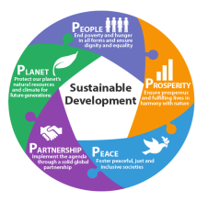Crucial to harmonise three core elements; Economic Growth, Social inclusion and Environmental protection.
* Eradicating poverty - indispensable requirement for sustainable development.
* Agenda places people at the centre of Sustainable Development.
* Going beyond silos and priority actions across interlinked goals.

**SDGs are:**

**Ambitoius Integrated Indivisible**

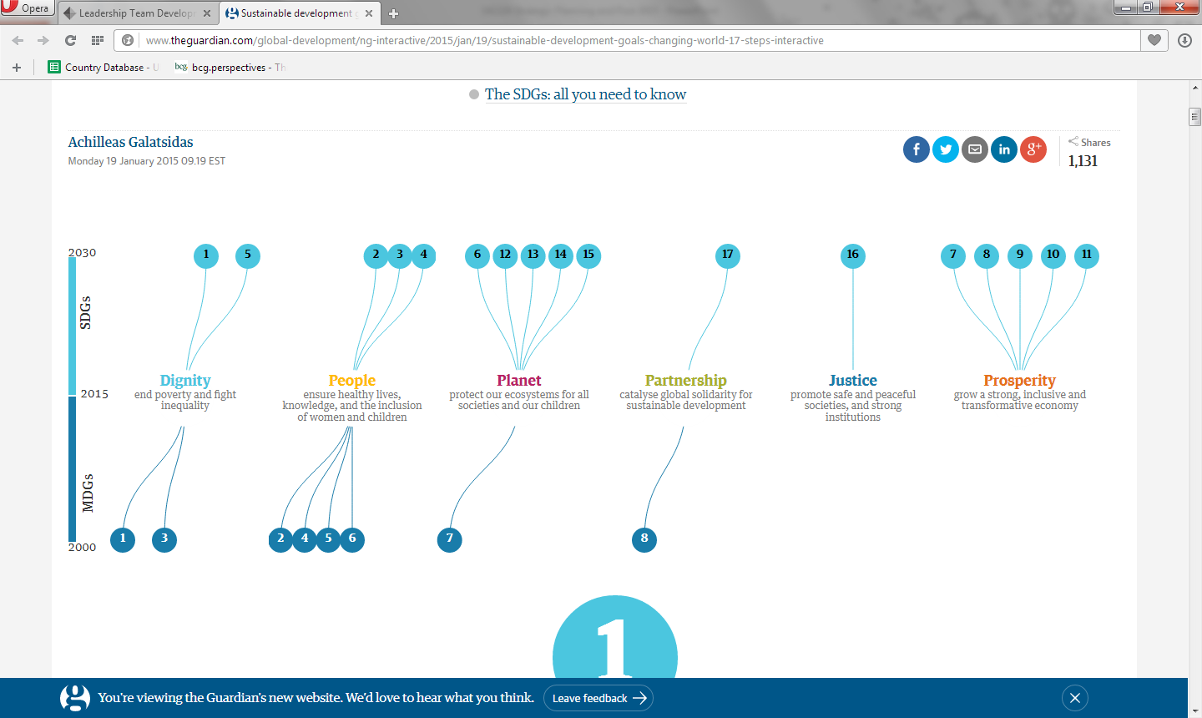

|  |  |
| --- | --- |
| **8 Goals and 21 targets** | **17 Goals and 169 targets** |
| **Top-down approach: result of an intergovernmental agreement and high-level consultations** | **Bottom-up approach: issued from an unprecedented consultation process (2012-2015)** |
| **Tackling poverty** | **Sustainable development** |
| **Developing countries** | **Universal** |
| **The world’s poorest and most vulnerable** | **The world’s population** |
| **Specific challenges** | **Integrated and comprehensive Agenda: covers the 3 dimensions of SD (economic, social and environmental)** |

|  |  |
| --- | --- |
| **Governmental** | **Inclusive: engagement of stakeholders**  **(LRGs, community based organizations, CSOs, private sector, academia etc.)** |
| **Statistical approach to localizing (urban rural disaggregation)** | **Comprehensive approach to localizing.**  **The local dimension of SDGs** |
| **Measurable through 60 indicators** | **Measurable through 232 indicators** |
| **Focus on aid flows and development**  **Cooperation** | **Focus on domestic resources to fund**  **sustainable development strategies** |





* Countries leading their own sustainable development policies, plans and programmes.
* SDGs will be a compass for aligning countries plans with their global commitments.
* Nationality owned strategies will require resource mobilization and financing strategies.
* All stakeholders: Government, civil society, the private sector and other expected to contribute to the realization of the new agenda in an integrated manner.
* Revitalized multi- stakeholder’s global partnerships to support national efforts.

* We live in “a time of immense opportunity”, with h the end of extreme poverty in sight.
* The key opportunities for Sustainable Development are:
* **Inclusive** (Government, International Organizations, Business, Public & Community).
* **Universal**- Apply to all countries and “involve the entire World, developed and developing countries like”, taking into account different national realities.
* **Integrated**- Moves away from soloed approaches to development and promotes the integration of the economy, environment, and society.
* **Locally**- **Focused**- Local Authorities and communities are responsible for the realization of the goals at local scales.
* **Technology Driven**- New technology offers tremendous opportunity to deliver public services, including healthcare, education, and basic infrastructure to more people at lower cost.



A screen shot of a video game

Description generated with high confidence

* The SDGs go beyond the MDGs in that they aim to address different sectoral objectives in a more systematic way and making sure that **no one left behind**, as well as acknowledging the linkages with other sectors.
* Analysis shows that more than half of the SDGs Targets makes an explicit reference to at least another goal which may facilitate **cross-sector integration of thinking**, policy and implementation.
* **Policy integration is nodded to bridge** the gap between the current silo institutional structures at National, State and Districts levels and the reality where different dimensions and sectors are interconnected.

**Policy integration can be defined as:**

* A process that should start from the early stage related to the definition of priorities and planning.
* Go through implementation and monitoring.
* And undergo reviews to allow Governments and other stakeholders learn from implementation and ensure accountability.

**Process of Implementation has to be:**

* Political
* Participatory
* Learning
* Linking National and Sub- National
* Ensuring cooperation of all stakeholders

|  |  |
| --- | --- |
| **Social**   * SDG 1 - No Poverty * SDG 2 - Zero Hunger * SDG 3 - Good Health and Well-Being * SDG 4 - Quality Education * SDG 5 - Gender Equality * SDG 6 - Clean Water and Sanitation | **Environmental**   * SDG 12- Sustainable Consumption and Production * SDG 13- Climate Action * SDG 14- Life Below Water * SDG 15- Life on Land |
| **Economic**   * SDG 7- Affordable and Clean Energy * SDG 8- Decent Work and Economic Growth * SDG 9- Industry, Innovation and Infrastructure * SDG 10 - Reduced Inequalities * SDG 11- Sustainable Cities and Communities | **Fostering Peace and Partnership**   * SDG16- Peace, Justice and Strong Institutions * SDG 17- Partnerships for the Goals |

* Global goals complement international conventions and other tools of international law by providing a globally shared normative framework that fosters collaborations across countries, mobilizes all stakeholders, and inspires action.
* Provide a shared narrative of sustainable development and help guide the public understands of complex challenges.
* Promote integrated thinking and put to rest the futile debates that pit one dimension of sustainable development against another.
* Support long-term approaches towards sustainable development.
* Define responsibilities and foster accountability.

* India has played an important role in shaping the SDGs.
* Countries national development goals are mirrored in the SDGs.
* **Commitment by the Central Government:**
* As reflects in the leadership by India in the Inter-Governmental negotiations, including the Sendai Frameworks; Addis Ababa Action Agenda; 2030 and Paris Climate Agreement.
* As evidenced in the statement of the Prime Minister and Senior Minister (External Affairs, MoEF, and Finance) at global meetings.
* **Entrusting responsibility to NITI Aayog:**
* To “coordinate the SDGs, ‘periodically collect data on the SDGs and ‘proactively fructify the goals and targets not only quantitatively but also maintaining high standard of quality’. Initial steps by NITI Aayog have included:
* Undertaking a mapping of SDGs goals and targeted with Schemes; identification of nodal Ministries and Government Departments for each of the Goals and Targets.

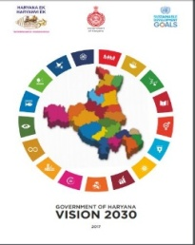A screenshot of a cell phone

Description generated with high confidence

Sustainable Development requires a long-term transformation,

Which in turns requires longer- term planning processes than the

Usual annual budgets or medium –term expenditure frameworks.

SDGs frameworks call for 15- year strategies that provide

A screenshot of a cell phone

Description generated with high confidence National roadmaps and coordinate stakeholders and activities for

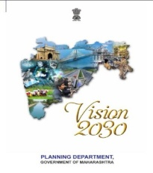 Collective actions.

Long- term Planning= Back casting problem- solving frameworks

That envisions intermediate actions based on long- term

Quantitative targets.

|  |  |  |
| --- | --- | --- |
| **VISION** | **STRATEGY** | **ACTION PLAN** |
| **15 Years long-term vision** | **7 Years mid-term strategy** | **3 Year short-term action plan** |
| **Combines international Sustainable Development Goals and national social goals** | **Converts a broader vision into implementable Policy** | **Translates Policy into action** |
| **Expands beyond traditional plan** |  | **Alignment to the predictability of the financial resources during the 14th Finance Commission Period.** |
| **Reflecting the country’s long-standing cooperative federalist tradition, these documents are being prepared with active participation of the sub-national governments** | | |

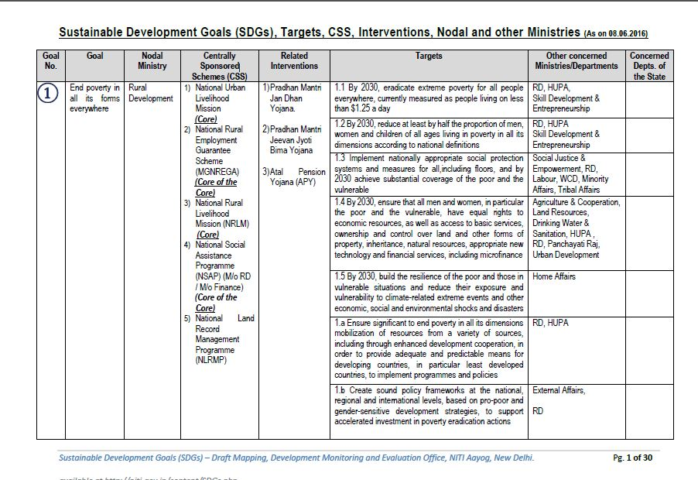z

Goal7: Ensure access to affordable, reliable, sustainable and modern energy for all

* States must mobilize adequate public and private resources to invest in key sustainable development areas.
* Conducting needs assessments to determine the volume of public and private investment required is a complex undertaking that will require significant work in most States/ UTs.
* On the basis of SDGs needs assessments Government can develop financing strategy that distinguishes between;
* a) Private financing opportunities.
* b) Incremental Government resource mobilization as well as opportunities for greater efficiency in Government spending, and where needed.
* c) International public financing (concessional and non- concessional)

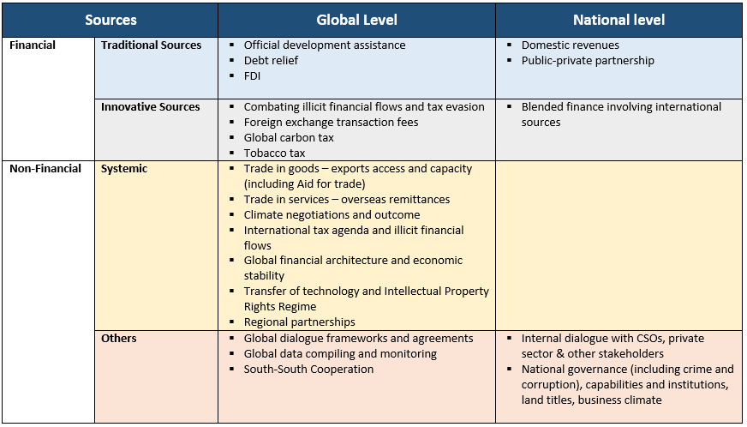

* **Scarce resources**- Hence alignment of budget with SDGs.
* **Improve management skills**- For effective uses:
* ***Resources***
* Improving organizations schemems, tax management, budgeting (including participatory budgeting), public procurements.
* **Mobilizing resources**
* New partnerships (Public-Private partnerships/ Public- Pricate people partnerships
* Alternative financing Channels (Crowd funding).
* Joint works plan for adjoining Local and Regional Governments (Ad-hoc associations/ Consortia/ Inter-NMunicipal Cooperations).
* Matching planned priorities with expenditure and resources

**Results based Budgeting**

* A mean for organizing and reporting a Governments allocation of fiscal resources along the lines of high- level goals.

**Budgeting for outcomes**

* Take the focus on performance further by creating a process for defining outcomes those citizens wants as the first step in budgeting process.

**Participatory Budgeting**

* Involving citizens directly in budgeting process

**Budget Mainstreaming**

* Integration of specific issue areas into fiscal budgets (e.g. gender; environment)
* **Helping to socialize the SDGs and mobilize communities:**
* Mobilize across sectors (health, education, etc) and geographic areas (rural, urban, etc.)
* Ensure that every single citizen understand what the SDGs are about (the 5Ps): ‘People, Planet, Prosperity, Peace and Partnership’- **National campaign**.
* **Leveraging existing technology:**
* Social media (twitter, online tools, chats, Face book,)
* Traditional media) TV, Radio, printed media…….)
* Community Radio and Private FMs.
* **Understand the entry point in the implementation of SDGs:**
* Support the Government to priorities.
* Implement actions on the ground.
* Help with resource mobilization to financing development.
* Localizing is the process of taking into account sub national contexts in the achievements of the 2030 Agendas
* From the setting of goals and targets,
* To determine the means of implementation,
* And using indicators to measure and monitor progress.
* SDGs have targets directly related to the responsibilities of Local and Regional Governments, particularly to their role in delivering basic services.
* Many of the investments to achieve SDG will take place in Local level only.
* Local and Regional Governments are well placed to raise awareness about the importance of the SDGs and their relevance to Local communities.

**SENSITIZING AND ENGAGING LOCAL STAKEHOLDERS – DISTRICT AND LOCAL COMMUNITIES ON SDGS**

*Mr. J.C. Phukan*

Consultant

Centre for SDG’s Assam Administrative Staff College, Government of Assam

**Introduction:**

Leaders from 193 countries got together in September 2015 at the United Nations General Assembly to adopt the Sustainable Development Goals (SDGs). India is also a signatory to this landmark agreement which set forth a set of seventeen goals which are to be achieved by 2030. Realizing the tremendous need for fulfilling the SDGs, Government of Assam followed the trial and become the first state in the country to adopt the SDGs through the issue of comprehensive Government Order in December 2015. Government of Assam is also the first in the world to have issued a ‘Vision Assam: 2030’ document in February 2016 and a composite vision and strategic Architecture Document titled ‘Assam 2030: Our Dream, Our Commitment’ was released on 3rd October 2016. It is also the first in the world to have formulated SDGs - oriented Budget in July 2016. Government of Assam has establish the centre for Sustainable Development Goals to guide, coordinate, train, spread awareness and understand on issues related to SDGs across all levels and stakeholders in the State.

**Institutional Framework:**

Transformation & Development Department is the nodal department for aligning the States activities to SDGs. The Centre for Sustainable Development Goals (CSDGs) was constituted in the Assam Administrative Staff College, Khanapara as knowledge center to guide and assist the departments for planning and monitoring of SDGs program in the state. Within a span of 2 years, the Centre for SDGs has been engaged in multifarious task ranging from conducting training /workshop for dissemination of SDG related information to the departments, councils, etc. to hold conclaves for finalizing Strategy papers and action plans of departments and developing framework for planning, implementing and monitoring SDGs. To bring knowledge the center has forged partnership with various stakeholders like UNDP, UNICEF, academic institutions and other organizations. Few Milestones in SDGs Implementation in Assam below;

**Capacity Building:**

9 training on SDGs for the officers of Assam Secretariat and directorates were held in AASC. In addition, number of workshops, conclaves and thematic discussions were held with departmental officers by the CSDGs.

**Localizing SDGs:**

One of the foremost objectives of the SDGs is to ensure that “no one is left behind”. For taking SDGs to the grassroots, a series of SDGs orientation workshops were held for District level officials in 19 out of 33 districts in the first phase from October 2017 to March 2018. The Autonomous Development Councils work closely with the community and are vested with several powers, it is crucial to orient them towards the fulfillment of SDGs. The training cum workshop sessions on SDGs for the Karbi Anglong Autonomous Council on 24th May, 2018 and Bodoland Territorial Council on 10th May, 2018 have been conducted by the Centre for the elected representative of the six Autonomous Tribal Councils were held on 21st, 26th and 30th June, 2018 in AASC.

**Incorporating Innovation of SDGs:**

The Centre for SDGs in collaboration with UNDP organized the Innovation Summit for facilitating innovation for SDGs. Additionally, an ‘Ideation’ was organized in which 26 teams from educational institutions participated and presenting ideas for innovation around health, livelihoods, unemployment, agriculture, nutrition deficiency, poverty and natural disasters and environment, for better implementation of SDGs. The prize money has been disturbed to the eight winning and runners up teams and is currently implementing their ideas on the ground.

**Outcome Budget: *Integrating SDGs to the Annual Budget*:**

Prioritizing SDGs expenditures through reallocation from areas of lower priority. Reallocating expenditures room non-SDGs (less priority) areas to SDGs priority areas is one of the first measures that will be employed for raising resources for the SDGs. The Government has already taken the first step in this direction by mapping expenditures to the outcome budget. The share for 2017-18 was 60%. A closer scrutiny of non-SDGs functions and expenditures will be carried out in 2018 which is expected to free additional resources to fill the gap.

***Assam Agenda 2030:***

The Assam Agenda 2030 has been based on inputs from the Strategy Paper & Action Plan (SPAPs) of departments and recommendations of nine conclaves as a document for incorporating strategies, interventions and actions for achieving SDGs in the state. The document is the culmination of an extensive process of consultation with departments, experts, and other stakeholders such as UN Agencies, Academicians and Researchers among others. It is the medium-term development agenda to guide the government department to initiate plans and programmes in convergence manner towards achieving the underlying theme of SDGs namely ‘No-one to be left behind’. The Assam Agenda : 2030 has nine chapters covering 17 SDGs and department primarily responsible for achieving the intended goals(s) is designated as ‘Lead Department’ and department(s) whose support is important to fulfill the objectives as ‘supporting department’. Other departments like WPT & BC, HAD etc. deals with all sectors of development is designated as ‘cross cutting department’.

Each chapter in Assam Agenda 2030 highlights a set of indicators with baselines and targets set for 2019-20, 2023-24, and 2030-31. The major strategic interventions proposed by the departments are highlighted along with technological inputs and innovations required partnerships to be developed and requirements in terms of financial infrastructural and human resources process of consultation and deliberation from multiple stakeholders in the state. The document has been approved but the State Cabinet and proposed to be unveiled by Hon’ble CM in September, 2018.

**MLA Interaction on SDGs:**

A two-day MLA interaction was organized by Hon’ble Speaker of the house on 26th and 27th February 2018.The two days saw participation from MLAs, experts both national and regional, bureaucrats from concerned departments and other important stakeholders of the state. The discussions focused on the Assam Agenda 2030 and understanding of SDGs and its context in Assam.

**District Manual and Process Documentation:**

The Centre for SDGs collaborated with UNICEF is preparing a District Manual Integrating SDGs in Development Process of Districts, Blocks and Panchayats. The document draft is now undergoing final review by the Centre for SDGs and to be submitted tops the T7 D Department for approval.

Further, a process document which highlights the journey of SDGs in Assam has been prepared in collaboration with UNICEF and is under the process of finalization in the Centre for SDGs.

**Proposed Activities:**

1. **Preparation of Assam Human Development & Sustainability Report 2019 :**

The Government of Assam has already finalized the 59 core indicators monitoring. In order to understand the performance of the state on SDGs, it is necessary to conduct household level survey to have a clear picture of the state’s performance on the indicators of SDGs. On the lines of the survey carried out in 2013-14 for the preparation of the second Assam Human Development Report (Published in 2016), the Centre for SDGs in collaboration with Omeo Kumar Das Institute of Social Change and Development under the administrative control of T & D Department will work towards the preparation of Assam Human Development & Sustainability Report 2019. The DES will be in-charge of conducting the household survey; while OKDISCD will offer technical support and CSDG will serve as the supervisory body.

1. **Monitoring of SDGS implementation in the state**

This extensive Assam Agenda 2030 encompassing goals and targets, their outcome indicators, required interventions and actions, and projects to deliver them will require an efficient and reliable information system updated timely and regularly for use of policy makers and managers of programs and schemes. Such a monitoring system is critical to assess progress being made on Assam 2030 and to make timely course corrections and adjustments. Such a monitoring framework will span two levels-outcomes, and projects and actions; require an efficient dashboard i.e. useful display platform for ease of assessing progress; and require statistical and organizational capacity to be built up quickly.

**A. Monitoring of outcomes**

Progress of Assam Agenda 2030 must ultimately be assessed by the final development outcome envisioned. These are measured through outcome indicators of which around 60 core indicators have been identified at the initial phase based on relevance and availability of data for monitoring. Each indicator has been benchmarked at 2016-17 and final (2030) targets and intermediate targets provided. In the future, improvements will be affected along the following lines:

**Expansion of indicator set.** This initial set will be refined and augmented to enable better monitoring, keeping in mind simplicity ( as too large a set is unnecessary and may lead to information overflow); and ease of data availability and costs of updating.

**Disaggregation.** State level averages do not provide sufficient information to enable better meaningful monitoring. In the case of Assam, it has been decided that at the minimum disaggregation would extend to Geographical dimensions including (a) Districts; (b) Char Areas; (c) Border Areas and Population groupings including (a) Gender; (b) Scheduled Castes, Scheduled Tribes, Other Backward Classes; (c) Tea Garden Labour Community.

**Periodicity of updating:** The data would be updated at least annually in most cases.

**B. Monitoring implementation of projects and actions.** Assam Agenda 2030 will be delivered through projects and key actions.

**Project monitoring:** The Assam Agenda discusses in each chapter key interventions necessary to achieve its goals and targets. These interventions in turn will be implemented through projects and schemes.

Following adoption of the Agenda, all Departments will conduct a review of the portfolio of projects and schemes supporting each identified interventions – which consist of (a) Centrally sponsored and supported project and schemes; (b) externally aided projects and schemes; and (c) state supported schemes. The review will result in a rationalization of projects including amalgamation, termination or expansion of existing projects based on an assessment of their usefulness.

The resulting rationalized list of projects will be taken up for close monitoring under the monitoring framework. For this purpose, project monitoring parameters will be established including physical targets and timelines for achieving them; and financial targets including disbursements and utilization of funds.

**Action monitoring**: Each intervention in Assam Agenda 2030 is also dependent on crucial actions including policy changes, organizational of institutional reforms, studies or reviews, forging of partnerships etc. Timelines within such actions will be adopted have also be set up. The monitoring framework will also monitor progress on the completion of such actions.

**C. Dashboard**

The monitoring parameters for both A and B levels will be displayed in a sample dashboard which will set up alerts in case progress on outcomes or projects or actions are falling behind schedule of not achieving desired result such as not reaching targeted groups etc. This will help managers of the Agenda at state and district level to initiate corrective action an s appropriate to place the state on track again to reaching targets.

**Progress in preparation of SDGs Dashboard**

In meeting with the Chief Secretary, Government of Assam on 14th march 2018, a proposal for developing an IT based platform for monitoring the important schemes/programmes which have significant contribution towards fulfilling the SDGs was discussed. The IT based monitoring platform with dashboard for the State will be developed by integrating the data from all the concerned Departments and monitoring will be done on quarterly basis on a dashboard with traffic light signaling. This dashboard will be password protected and will be accessible to the highest rank officials of the State government. The one to one consultations with the Departments are in progress in the Centre for SDGs in collaboration with the Transformation of and Development Department. A total of 97 Flagship Programs/ Schemes have been shortlisted for monitoring, out of which 44 are centrally sponsored, 53 are State sponsored and one is externally funded. The rationale for short listing of the programmes and schemes are as follows:

* Only schemes of financial outlay above 10 crores to be shortlisted
* Only schemes directly contributing to the SDGs to be considered.
* At least one program from each department is to be mapped. In case of departments having no schemes above 10 crores, a cluster of similar projects may be mapped under one scheme.

**Way Forward:**

The Additional Chief Secretary, T&D Department has review the progress of Implementation of SDGs in Assam on 20/8/2018 and finalized a time bound work plan towards effective implementation of the program in the state as below.

|  |  |
| --- | --- |
| Activities Proposed | Timeline |
| * Assam Agenda 2030:   -- Unveiling by the Honorable CM | Sept,2018 |
| * SDGs Monitoring Dashboard:   -Pilot unveiling of Project Monitoring dashboard  -Full; fledge dashboard | Nov,2018  March, 2019 |
| Framework for reducing inequality | Nov,2018 |
| * Capacity building: * SDGs Dashboard: Dept. SDGs Nodal Officers & data inputting officers- * District level: key officers district and blocks on SDGs manual- * GP level: new elected PRI members | Dec,18  Jan-June 2019  Dec, 2019 |
| Linking outcome budget with SDGs | Sept,2018 |
| Approval of District SDGs Manual | Oct,2018 |
| Human development and Sustainability report 2019 | Nov,2019 |

***DELIBERATIONS***

1. In order to address the different sectoral targets of Sustainable Development Goals and to ensure that ‘no one is left behind’, there is a need for Policy coherence. This issue can be addressed by developing context relevant instruments and system and by involving all stakeholders – at village, district and regional levels and create holistic approaches through interdisciplinary measures in information gathering and exchange.
2. Promotion of Policy Integration. This entails acknowledging the linkages. More than half of the Targets have an explicit reference to another goal at least which may facilitate sectoral integration of policy and implementation. There is a huge need to bridge the gap between the current silo institutional structure at national, state and district levels and the reality where different dimensions and sectors are interconnected.
3. Goal-based planning which will help in guiding public understanding of the complex challenges. The Goals and Targets of SDGs complement international conventions and other tools of international law which mobilizes all stakeholders defining responsibilities and accountability. This will require long term planning process ensuring long term transformation thereby emphasizing upon the institutional as well as structural changes.
4. Local and Regional governments are essential for promoting sustainable development within their territories and they are, therefore the necessary partners in the implementation process. Effective local governance can ensure inclusion of diversity of local stakeholders thereby creating broad-based ownership, commitment and accountability. It is imperative that the start government must provide adequate legal frameworks as well as institutional and financial capacity.
5. Capacity building – organizational and institutional needs to be transformed. This necessitates both external and internal assessment. Mobilization of multi-stakeholder initiatives among civil society, private sector organizations and other agencies. It is crucial to ensure involvement and participation of all stakeholders particularly the vulnerable and marginalized sections to strengthen responsibility and better outcome.
6. Leveraging technology and innovation in the process of implementation. New ideas in relation to health, livelihoods, unemployment, poverty, environment, natural disaster and agriculture are essential and may be incorporated in the process. Metadata will help in data standardization, integration and harmonization across the states. Localization and data disaggregation in the context of national framework is also important. It is therefore, improvement in the State’s data machinery is crucial to regularly produce and compile the data.
7. Setting up of monitoring mechanism at the local level led by local leaders. This can be achieved by involving citizens and inculcating a sense of partaking. Utilizing the adopted SDGs indicators for monitoring the effectiveness of local plans and due recognition at the state and higher levels will also help in identifying the gaps and bridging gaps in the process.

Local Government is crucial in turning Agenda 2030 from a global vision into a local reality. And local communities and stakeholders, who know individual and collective needs and capacities best, are critical partners in implementing and realizing our global accord. More than ever, we need to bring together National and Local Governments, the private Sector, Civil society and non- traditional players in the development arena such as foundations, social enterprises, traditional leaders, religious organizations and Academician.

Thus, it was concluded that all goals of SDGs are directly related to the responsibilities of local and regional governments particularly to their roles in delivering the basic services. Local spaces are the ultimate key site of delivery and development. As such, local government is central to the success of sustainable development. They can approach goals and targets in a pragmatic way by fitting them into their own particular context and help citizens in mobilization and thus optimizing their participation level and contribution.